[Accepted Version]

Personnel Power: Governing State-Owned Enterprises

Forthcoming in Business and Politics

Wendy Leutert
Indiana University
wleutert@iu.edu
Samantha A. Vortherms
University of California, Irvine
s.vortherms@uci.edu

Abstract
State-owned enterprises (SOEs) retain a strong presence in many economies around the world. How do governments manage these firms given their dual economic and political nature? Many states use authority over executive appointments as a key means of governing SOEs. We analyze the nature of this “personnel power” by assessing patterns in SOE leaders’ political mobility in China, the country with the largest state-owned sector. Using logit and multinomial models on an original dataset of central SOE leaders’ attributes and company information from 2003 to 2017, we measure the effects of economic performance and political connectedness on leaders’ likelihood of staying in power. We find that leaders of well-performing firms and those with patronage ties to elites in charge of their evaluation are more likely to stay in office. These findings suggest that states can leverage personnel power in pursuit of economic and political stability when SOE management is highly politically integrated.

Keywords
state-owned enterprises, state-business relations, China, political mobility

Citation
Leutert, W., & Vortherms, S. (2021). Personnel Power: Governing State-Owned Enterprises. Business and Politics, 1-19. doi:10.1017/bap.2021.5.

Introduction
State presence in the economy remains strong worldwide. State-owned enterprises (SOEs) rank among the largest firms in both emerging and advanced capitalist economies. Some countries have even expanded state ownership by creating new SOEs or nationalizing existing firms. These developments defy long-standing arguments that state ownership should be minimized or eliminated due to lower enterprise efficiency, productivity, and profitability. SOEs persist because they serve crucial economic and political functions for governments: generating revenues via dividends and taxes, supporting employment, keeping key input prices low, responding to natural disasters and other crises, channeling capital toward targeted sectors and technologies, and supplying political elites with rents.
How do governments manage these firms? SOEs are important entities for states to control because they represent significant economic and political value. One key tool is “personnel power,” authority over SOE executive appointments. Systems of SOE executive appointment worldwide vary from market-oriented to political-oriented. On the market end of this spectrum are systems in which SOE boards of directors choose their executives instead of state appointments, approvals, or nominations. At the other end are systems in which SOE executives are themselves government officials or high-ranking members of the ruling elite.
We examine how personnel power is exercised in China, a context in which SOEs are highly politically integrated. China is an important case because its state sector is the biggest in both global and domestic terms. China has the largest total number of SOEs and also the highest share of SOEs among its biggest companies. SOEs contribute an estimated 23 percent of the country’s GDP and constitute a vital part of its industry and equity markets: they account for 28 percent of industrial assets, as well as approximately 40 percent of total market capitalization and 50 percent of revenues of publicly-listed companies. Moreover, Chinese SOEs have long provided the majority of overseas direct investment. How the government manages SOEs therefore significantly affects both the domestic and global economies. Comparatively, the Chinese case may offer insights into the balance of economic and political factors in SOE management in other politically-oriented systems.
We leverage original data to conduct the first systematic analysis of China’s governance of its largest SOEs via executive appointments. Specifically, we investigate the factors affecting the political mobility of the leaders of China’s 53 core central SOEs—who stays in the state-owned economy, who gets transferred to the government, and who exits. We use logit and multinomial logit models to analyze the attributes of top leaders and all central SOEs with vice-ministerial rank equivalence from 2003 to 2017. Specifically, we test if core central SOE leaders are rewarded for delivering positive economic performance or are moved to other positions for reasons of political connectedness.
Our findings are twofold. First, we find that better economic performance decreases the likelihood of a SOE leader exiting executive life and being transferred to a government position. Second, we find that SOE leaders are more likely to stay in their posts if they have informal connections to the political elites in charge of their evaluation; the more connections they have, the more likely they are to stay in the state-owned economy rather than exit or move into government. Put simply, China’s Party state retains SOE executives who deliver on the bottom line and are connected with the leadership of Party and government organs responsible for personnel and enterprise administration. At the same, it rewards those who have accumulated government experience and Party training with possible political advancement. These findings suggest that in contexts like China where SOEs are highly integrated with the state apparatus and ruling elites, personnel power can function as an instrument for economic and political stability.

SOE Management Around the World
SOEs serve vital economic and political functions for governments, making state management of these firms an important issue for comparative politics. Dividends and taxes from SOEs often constitute a significant source of government revenues. State firms also support stability by providing employment, keeping key input prices low, and responding to natural disasters, financial crises, and public health challenges. They facilitate industrial policy, national development, and economic statecraft by channeling capital toward targeted sectors and technologies and executing major infrastructure projects at home and overseas. They also supply political elites with an important source of rents.
Many governments use authority over executive appointments as a key method of governing SOEs. The logic is simple: control the leader, control the SOE. SOE executives directly affect firm organization and behavior by making and executing choices about strategy and structure. Specifically, SOE leaders choose whether and how to respond to state directives and changes in external economic and political environments. They also shape corporate structure by creating, eliminating, or modifying departments; altering internal hierarchies of authority; and reallocating assets, capital, and personnel. As more SOEs operate outside of their home countries, SOE executives’ decisions now affect markets, communities, and environments worldwide.
SOE executive appointment systems worldwide vary from market-oriented to political-oriented (Figure 1). On the far market end are systems in which SOE boards of directors select executives. Such systems are few in number and located predominantly in advanced capitalist economies, including Australia, Germany, New Zealand, Norway, and Sweden. Other countries blend a primarily market orientation with limited state involvement. For example, South Africa permits SOE boards of directors to select executives subject to consultation with and final approval by state authorities. In these systems, SOEs are managed like private firms, with market forces driving executive assessment and selection.

Figure 1: Spectrum of SOE Management Systems

Market-Oriented Political-Oriented

State has weak personnel power State has strong personnel power
SOEs more independent from state apparatus SOEs highly integrated with state apparatus
Market factors drive SOE leaders’ careers Political factors drive SOE leaders’ careers

On the far political end are systems in which the state chooses SOE executives and they are highly integrated with the state apparatus and ruling elites. Paradigmatic cases include Gulf states like Qatar and Bahrain, where members of the ruling family personally select executives and can themselves serve as SOE leaders. In Russia, top presidential administration officials and ministers routinely serve concurrently as the chairmen of the largest SOEs; the state can also bypass boards to appoint CEOs. In these systems, firms act more like bureaucratic government organizations than fully marketized entities.
Between the extremes are blended types where governments may appoint leaders, but SOE executives vary in their connectedness with the political elite. In South Korea, for example, the president directly appoints the heads of SOEs, typically choosing individuals who are former political allies but who do not serve concurrently as government officials. In Austria, government ministries retain primary powers of appointment over top management positions in state firms, with ministers who are unconstrained by watchdog junior ministers more likely to appoint SOE executives who share their partisan affiliation.
Factors affecting the state’s exercise of personnel power vary depending on where a system of SOE executive appointment falls on this spectrum. Toward the market-oriented end, firm performance should better explain SOE executive career trajectories because the state interferes less, allowing markets to determine outcomes. However, toward the political-oriented end, firm performance alone is unlikely to account for who gets and keeps leadership positions. Instead, political factors like ties with higher-level officials or previous work experience must also be considered. While market forces may play a role, the interconnectedness of government and SOEs creates greater opportunities for political factors to matter.
This study focuses on one case of a highly politically-oriented SOE executive appointment system: China. Beyond its theoretical importance as a paradigmatic politically-oriented system, the China case is substantively significant because of Chinese SOEs’ economic might and because it is a bureaucratically defined system of oversight and authority, discussed below. Lessons from China may thus be informative for other contexts where political units have formal authority over leadership appointments.

SOEs in China
Today, China has 97 central SOEs—non-financial companies owned by the central government and administered by the State-owned Assets Supervision and Administration Commission (SASAC). Core central SOEs are a subset of these firms: their vice-ministerial rank equivalence sets them apart from other central SOEs with department-level rank equivalence. This means that leaders of core central SOEs have a bureaucratic rank equivalent to government officials like mayors. Most core central SOEs are concentrated in strategically important sectors with restricted competition, such as defense, petroleum, electricity, aviation, and telecommunications, while some operate in more competitive industries like electronics and automobiles. This sectoral distribution mirrors other countries. Core central SOEs are typically structured as large enterprise groups, with as many as 100 to 200 member entities—including joint venture firms, research institutes, and publicly listed subsidiaries—arrayed under a holding company wholly owned by SASAC.
The Central Organization Department (COD), the Chinese Communist Party (CCP) department responsible for managing all leading officials in China, directly appoints, transfers, and removes core central SOE leaders. Specifically, the core central SOE leaders that the COD manages are the individual(s) holding the positions of Party secretary, general manager, and board chairman. The COD has personnel authority for these executives even though the firms they lead are formally under SASAC administration. As Mark Wu (2016) puts such an institutional arrangement in comparative terms: “Imagine if one U.S. government agency controlled General Electric, General Motors, Ford, Boeing, U.S. Steel, DuPont, AT&T, Verizon, Honeywell, and United Technologies. … It could hire and fire management, deploy and transfer resources across holding companies, and generate synergies across its holdings” (272). Because the COD, a key Party organization, has final say over personnel appointments, there is a clear institutional pathway for political influence over SOE management. Figure 2 below depicts the administrative hierarchy and organizational structure of core central SOEs in China. The division of administrative and personnel authority in China’s core central SOEs creates the potential for both economic and political factors to influence leader mobility, making this group of SOE leaders a crucial case for differentiating between their effects.

Figure 2: Administrative Hierarchy and Organizational Structure of Central SOEs in China

Central Organization Department
Non-Core Central SOE
Core
Central SOE
Member Entities
State-Owned Assets Supervision and Administration Commission
Personnel Authority
Administrative Authority
Holding Company
State Council

Core central SOE leaders are comparable to other leading Chinese officials because of their formal bureaucratic status—their administrative rank equivalence—and their political management by the COD. Core central SOE executives are almost invariably Han Chinese men between 50 and 60 years old. Virtually all have at least a college education, similar to leading local officials like provincial governors and Party secretaries. Core central SOE heads typically assume their positions after decades spent working their way up gradually within a particular industry and sometimes even within a particular firm. They routinely move on into Chinese civil service positions in local and central government, although their rates of political circulation and age-mandated retirement are lower than those of other officials. It is extremely rare for core central SOE leaders to cross over to the private sector, even though exits from the public sector are becoming more common for local officials.

Personnel Power and SOE Executives
Because Chinese SOE leaders are administratively similar to other officials in the state bureaucracy, existing research on political mobility provides a starting point for analyzing SOE leader mobility. Numerous studies find a positive correlation between economic performance and political advancement. This positive relationship is theorized to drive a meritocratic growth model in which the CCP’s cadre management system incentivizes and rewards economic performance. Other scholarship finds that political connectedness and patronage ties improve officials’ career prospects. Another body of work suggests that economic performance has a greater effect at lower levels and for individuals in government positions, whereas political connectedness matters more at the central level and for Party posts. Still others argue that economic performance itself may be partly endogenous to political connections.
Scholarship specifically addressing central SOE leaders is growing but remains limited. Yang, Wang, and Nie (2013) find that economic performance, membership in the Central Committee of the CCP, and having a Ph.D. degree all boosted the likelihood of individuals advancing within and beyond the top ranks of central SOE management between 2008 and 2011. Brødsgaard et al. (2017) look inside central SOEs to find that economic performance positively affected the internal promotion of subsidiary heads between 2003 and 2012. Other studies focus on central SOE leaders’ career trajectories, political connectedness, and institutional integration within China’s political system.
These works provide important insights but have highly restricted empirical and chronological scope. Multiple studies combine leaders of core and non-core central SOEs in their analyses or aggregate intra-firm and post-firm advancement as a single dependent variable; however, this is unadvisable because different bodies appoint the leaders of core and non-core SOEs and the determinants of intra-firm promotion and post-executive leadership movements are likely to differ. Other work only examines intra-firm promotions of subsidiary heads, not the mobility of core central SOE leaders. The short timeframes in existing research—only one year in Lin (2017) and four years in Yang, Wang and Nie (2013)—constitute a further analytic obstacle. Our analysis of personnel power in China—how the government uses executive appointments to govern SOEs—advances these studies by systematically assessing the factors affecting political mobility for all core central SOE leaders between 2003 and 2017.

The Exercise of Personnel Power
How does the CCP exercise personnel power? Are market forces correlated with personnel management, or do political connections define the career paths of China’s core central SOE leaders? Economic performance is one possible explanation for political mobility. SOEs’ economic performance is of vital concern to the state: they contribute 30 percent of government revenues and account for 40 percent of market capitalization of companies listed on the Shanghai and Shenzhen stock exchanges. SOEs also support economic stability by helping to avert financial turmoil, for example by enabling the coordinated resumption of Chinese industrial production during the COVID-19 pandemic and arresting sell-offs during 2015 Chinese stock market volatility. Improving SOEs’ economic performance has been a longstanding policy goal in China; state intervention to restructure poor performers further underscores the imperative for core central SOE leaders in all sectors to deliver positive economic performance. Indeed, SASAC requires central SOE leaders to sign responsibility contracts for firm performance and charges them with fulfilling what director Hao Peng describes as an economic “stabilizer” function. Together, these factors suggest that firm performance could influence leader outcomes. Choosing to retain SOE executives who deliver positive economic performance helps to aid government solvency and avert financial turmoil, whereas removing or transferring well-performing SOE leaders risks potentially destabilizing firm performance and broader growth.
Publicly available information indicates that economic performance is vital to performance assessment for core central SOE leaders. Chinese SOEs routinely compete with one another and with foreign firms, both at home and abroad. The state expects central SOEs to at minimum make profits, even if not necessarily to maximize them. Even so, maximization of operational profits is still listed first among the principles on which SASAC’s performance assessment system was originally based. In central SOE assessment measures issued by the COD and SASAC on a trial basis in 2009, fully half of the proposed evaluation scheme was based on operational performance metrics, more than any other area assessed. The most recent publicized evaluation measures urge SOE leaders to boost efficiency, optimize resource allocation, improve labor productivity, and increase capital returns. Every year, SASAC measures top executives’ success in achieving economic performance targets based on the preceding year’s results, and it assigns them a grade from A to E that determines their compensation relative to a fixed baseline. There is limited information publicly available about how SASAC’s grades ultimately factor into the COD’s decisions about political mobility for the core central SOE leaders under its personnel control. However, the fact that all central SOE leaders receive SASAC grades suggests that the COD does take them into account together with other factors, including individuals’ qualifications for particular posts and even their personal preferences. Knowing that maintaining high-performing leaders supports economic stability and that economic performance is a key element for annual review, we expect: leaders of higher performing firms are more likely to maintain their positions than exit the state-owned economy.
Political connectedness is another potential determinant of SOE executive management. In systems where the management of SOEs is highly integrated with the political system and ruling elites, political connectedness is expected to be the primary driver of personnel decisions. Of primary interest here is political connections through patron-client relations. SOE leaders are clients of three types of higher-level officials: central Party leaders, the COD—the department ultimately responsible for personnel decisions—and SASAC leaders—those in charge of annual reviews used by the COD to evaluate SOE leaders. Based on reciprocal accountability arrangements, political leaders rely on SOE executives to provide political and economic goods via their firms while SOE executives depend on political leaders for their jobs.
Although informal connections are criticized for potentially undermining meritocratic, rules-based governance, they can boost political stability in multiple ways: by aligning interests, solving information problems, fostering mutual trust, sustaining cooperation, and improving communication within the state bureaucracy. Political connectedness, then, increases transparency between patron and client, decreasing the information asymmetry present in all patron-client relationships. These ties have been shown to increase the probability of political advancement in other areas of the bureaucracy. Patrons are incentivized to keep “their people” in the game longer, benefiting from broad networks creating a constant pool of political allies. Encouraging one’s allies to stay in positions of power creates political stability by widening politician networks and constituencies of support. Because of this, we expect: leaders with patronage political connections are more likely to stay in the state-owned economy than exit.
A final potential determinant of personnel power is the professional history of SOE leaders themselves. In politically oriented systems such as China, SOE leaders are more likely to have had previous work experience in the formal government bureaucracy because of the intertwined nature of the state and economy. Formal work experience in the state apparatus allows SOE leaders to gain familiarity with rules and expectations for political advancement and to demonstrate loyalty to the ruling regime. Since such work experience also provides an opportunity for socialization, network building, and exposure to government positions, we expect: former work experience in the state apparatus increases the probability of being transferred into government.

Methods and Data
To evaluate the determinants of leaders’ political mobility, we use an original dataset of 243 leaders of all core central SOEs in China between 2003 and 2017, which yields a total of 1,231 leader-year observations. We focus on core central SOEs because the clear lines of economic oversight by SASAC and political oversight by the COD allow us to more clearly identify potential patron-client relationships. Because of China’s politically-oriented system of SOE management and the high ranking of core central SOEs with well-defined channels of authority between their leaders and the CCP, this study presents a case where political connections appear most likely to influence mobility outcomes. For inclusion in our sample, an individual must hold at least one of the three top leadership positions in a core central SOE—Party secretary, general manager, or chairman of the board of directors—for at least six months. Information about these leaders’ backgrounds and career trajectories was compiled from their official CVs, media reports, company websites, and the Chinese Political Elites Database hosted by National Chengchi University.

Dependent Variable
The dependent variable is political mobility: a core central SOE leader’s probability of leaving his position of executive leadership. As discussed below, we operationalize political mobility in two forms—power continuation and sectoral change—to capture the dynamics of leaders’ careers. Broadly speaking, political mobility has multiple potential outcomes: exit through retirement, death, or corruption removal; transfer to an executive post at another central SOE; or appointment to a position in government at either the local or central level. Given these possible outcomes, staying in position is, naturally, the most common outcome for leaders—leaders maintain their position on average 86 percent of the time, while the frequency of other mobility outcomes varies by year (Table 1). Descriptively, there were more transfers between SOEs in the Xi Jinping era (post 2012) than during the Hu Jintao period, but transfers to government positions do not show specific trends. Conceptually, we group lateral transfers to another SOE leadership position with staying in one’s position because neither rank nor sector changes.

Table 1: Leadership Mobility Outcomes for China’s Central SOE Leaders

 | 2003 | 2004 | 2005 | 2006 | 2007 | 2008 | 2009 | 2010 | 2011 | 2012 | 2013 | 2014 | 2015 | 2016 | 2017 | Total
Same position | 54 | 53 | 67 | 59 | 63 | 67 | 76 | 76 | 83 | 88 | 82 | 78 | 70 | 75 | 73 | 1,062
Retired | 8 | 10 | 3 | 6 | 2 | 4 | 4 | 4 | 2 | 2 | 5 | 5 | 8 | 5 | 2 | 70
SOE Transfer | 1 | 3 | 1 | 2 | 1 | 3 | 0 | 3 | 1 | 1 | 2 | 6 | 12 | 7 | 2 | 45
Local Govt. Transfer | 2 | 1 | 0 | 2 | 3 | 0 | 0 | 1 | 1 | 2 | 2 | 1 | 1 | 1 | 0 | 17
Central Govt. Transfer | 0 | 0 | 0 | 2 | 2 | 3 | 0 | 2 | 3 | 3 | 3 | 1 | 0 | 0 | 3 | 25
Died | 0 | 0 | 0 | 0 | 1 | 0 | 0 | 0 | 0 | 0 | 0 | 0 | 1 | 0 | 0 | 2
Corruption Removal | 0 | 0 | 0 | 0 | 1 | 0 | 1 | 0 | 0 | 0 | 2 | 4 | 3 | 0 | 0 | 11
Total | 65 | 67 | 71 | 71 | 73 | 77 | 81 | 86 | 90 | 96 | 96 | 95 | 95 | 89 | 80 | 1,232
SOURCE: Authors’ dataset.

Leaders can exit by retiring, dying while in office, or being removed for corruption. Core central SOE leaders are required to retire at the age of 60, although this rule is often violated. Corruption removals occur throughout the study’s timeframe and more frequently under the Xi administration than the Hu administration. Nine of 11 corruption removals occurred from 2013 to 2015, a time when the Central Commission for Discipline Inspection targeted core central SOEs for investigation. Retirement may also mask corruption: officials may be pressured into retirement or retire early to avoid a corruption probe, thereby making it difficult to discern between genuine and forced retirement for disciplinary purposes. In our dataset, approximately ten percent of those who retire do so before the age of 60, with the youngest being 54, but reasons for early retirement are unknown. We therefore follow the standard practice in the political mobility literature of employing a single termination category combining retirement, death, and corruption removal into one “exit” outcome.
It is also important to note that formal demotion due to poor performance is not a common occurrence in the Chinese context. Poorly performing leaders are often not formally demoted or punished but rather transferred laterally to another position of the same rank in a less important unit. Within our dataset, only two individuals were “demoted” with a move to a non-core central SOE. It is therefore neither internally valid nor empirically valid to separate out this mobility outcome.
Another possible political mobility outcome for core central SOE leaders is appointment to positions in government at either the local or central level. Most movements within state-owned industry or to government are lateral transfers to same-ranked positions (vice-ministerial) rather than a promotion upwards to ministerial rank. However, a small number of core central SOE leaders have ultimately achieved positions of full ministerial rank through government pathways at both the local and central levels, thereby showing that either government pathway does offer a potential route to political promotion.
We measure political mobility in two forms. First, we measure mobility as a dichotomous variable of power continuation. Remaining in one’s position, moving to a different SOE, or being transferred to the government are scored as one and termination through retirement, death, or corruption removal are scored as zero. This measurement captures who gets to “stay in the game” rather than exiting the political system, which is generally seen as more desirable because power continuation allows continued access to resources and power. Second, we separate out different mobility outcomes to disaggregate the various ways in which leaders maintain power. A three-category variable, mobility, captures sectoral changes by measuring outcomes as exit, stay in the state-owned economy, or transfer to a government position. While moving to the government is the only pathway to political promotion, we use a categorical variable because we do not assume that staying in the state-owned sector or moving to government are intrinsically ranked as better or worse outcomes for leaders.

Independent Variables
We assess core central SOEs’ economic performance by measuring the performance of their largest (by assets) publicly listed subsidiary in each year. Since these publicly listed subsidiaries typically contain the best quality productive assets from core central SOEs, their performance represents a conservative upper bound for that of the overall enterprise group. While performance data for entire enterprise groups would be preferred, this data is largely unavailable because Chinese regulatory authorities do not require its disclosure. We follow the literature to take return on assets (ROA) for the largest listed subsidiary as our primary measure of firm performance. Average ROA for the core central SOEs over time is presented in Figure 3. Variation in firm performance occurs both across firms and over time, with greatest variation among firms during financial downturns and stock market crises. To reduce the variation in performance measures due to these factors, we also include a differenced measure of ROA. Alternative measures of firm performance, including negative performance, are discussed below.

Figure 3: Average ROA for Central SOE Largest Subsidiary Over Time, with 95% Confidence Intervals

The second key independent variable is political connectedness. Measures of political connectedness are hotly debated and include birthplace networks, occupational proximity (defined as work and military experience in the same place at the same time), co-worker networks, and patronage ties. We conceptualize political connectedness as patron-client relations. A core central SOE leader is considered politically connected to a patron if the superior during whose tenure he was initially appointed is still in office. For example, a core central SOE leader appointed in 2003 is considered politically connected to Hu Jintao, who was Party Secretary at the time of appointment, until 2012 when Hu leaves office and Xi Jinping assumes leadership. The logic of this measurement is that initial appointment is more likely to signal connections and patronage relationships than more diffuse birthplace or workplace-based ties.
We measure patronage ties at three levels: the national administration (Hu or Xi), SASAC (particular SASAC directors), or the COD (particular COD directors). Elite factions linked to China’s top leader may be politically salient, especially for central-level officials like core central SOE heads. Economically, SASAC is responsible for overseeing and assessing core central SOEs’ economic performance and grading their executives annually from A to E, which presumably affects their political mobility prospects. Politically, the COD exercises ultimate decision-making authority over core central SOE leaders’ appointment, transfer, and removal. At each of these three levels, changes in individual patrons might affect political mobility because different leaders may have varying priorities and approaches to personnel management. We do not assume that core central SOE leaders know their patrons personally, although this is quite likely given their status as central-level officials.
The third set of measures captures professional experience. First, we measure whether a core central SOE leader has any previous work experience in a government or Party position at the local or central level prior to his SOE leadership position. Previous experience is measured as a dichotomous variable disaggregated by level: central and local. Professional experience is also measured at the firm level through leadership tenure. Longer leadership tenure may be a boon to political advancement as it signals depth of leadership experience.

Control Variables
Previous professional experience is one control of particular interest. We use dichotomous variables for experience in local or central government and a continuous variable for number of years in one’s leadership position.
There are four sets of control variables for this analysis: individual traits, Party training, firm traits, and time period controls. Individual traits include age and education. Because the mandatory retirement age is 60 for officials of vice-ministerial rank, we expect age to be positively correlated with exit. Age squared is included to capture any non-linear effects of age. Education may increase the probability of promotion, because of the Party’s ongoing efforts to professionalize cadres. We therefore include an indicator variable for graduate degree (MA or Ph.D.) to assess the effects of advanced educational attainment. Some leading officials participate in formal training courses for mid-career cadres at the Central Party School. These schools provide a structured means of socializing officials within the Party and potential networking opportunities. We also include industry fixed effects. Firms are identified by their industry according to internal SASAC classifications to control for differential treatment of firms by industry. Finally, we include an indicator variable for regime effect measuring Xi Jinping’s administration (the first term in 2013-2017).
A summary statistics table is available in the Appendix (Table A3).

Modeling Strategy
We implement a series of logit and multinomial logits to assess the relative determinants of political mobility. In the initial set of models, the dependent variable is a discrete binary variable of power continuation, where 1 indicates staying in one’s position or a subsequent appointment to another executive or government post and 0 indicates exit (retirements, deaths, and corruption removals). The second set of models conceptualizes the dependent variable as a three-category mobility measure, where -1 indicates exit, 0 indicates staying in position, and 1 indicates lateral movement to another central-level SOE position or any government position.

Results
Power Continuation
The first set of models presents logit models on the correlates of power continuation (Figure 4). Exit from professional and political life means giving up access to economic and political power gained from a formal position, whereas power continuation means a leader gets to “stay in the game”—continuing to exercise influence and potentially earn rents from his formal position. Performance is positively and significantly correlated with power continuation. Both measures of good performance, ROA level and differenced ROA, are positive and significant (p=0.45 and 0.10, respectively). Correspondingly, negative ROA growth, measured as one if ROA declined over the previous year and 0 otherwise, is negatively correlated with power continuation: having negative ROA growth results reduces the probability of power continuation by 3.6 percent (p=0.07). This suggests that leaders who oversee more profitable firms, both overall and compared with the previous year, are more likely to stay in their position than exit.

Figure 4: Marginal Effects Power Continuation, Logit Models with 90% and 95% Confidence Intervals

Panel A Economic Performance Panel B Political Connections
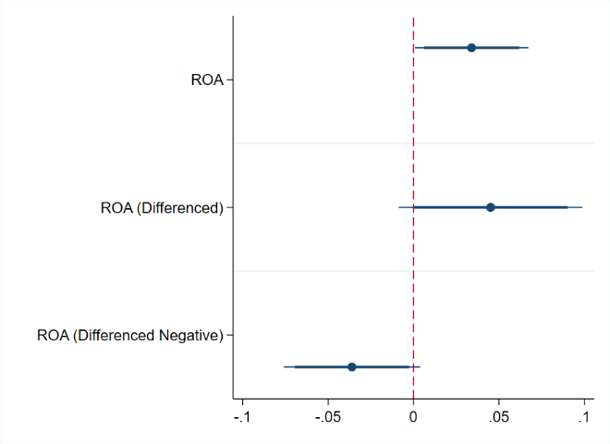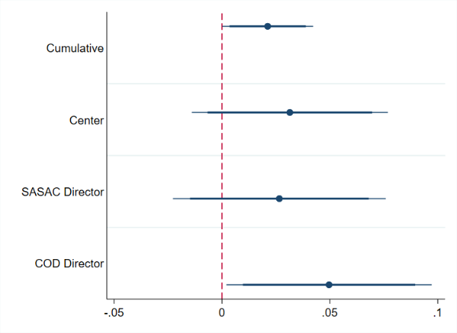
All models include controls for age, experience, and SOE industry. Models in Panel A include cumulative connections while models in Panel B include control of ROA. Full results available in appendix tables A4 and A5.

Panel B presents the marginal effects of three levels of patron-client ties on power continuation. For power continuation, only connection to the COD is statistically significant on its own. However, cumulative connections also increase the probability of staying in power, providing some evidence that patron-client relationships matter but depend on the connection. Leaders without political connections have a predicted probability of continuing their position of approximately 88 percent whereas those with political connections at any of the three levels is approximately 92 percent. Connection with the COD director has a slightly larger effect on probability of power continuation, but this difference is not statistically significant.

Table 2: Marginal Effects of Patron Connections at Three Levels on Power Continuation and Mobility Outcomes

 | Power Continuation | Multi-level
 |  | Exit | Government | Baseline: SOE
 | (1) | (2) | (3) | (4)
Central Administration | 0.031  (0.023) | -0.033*  (.018) | -0.007  (0.017) | 0.040*  (0.024)
SASAC Director | 0.027  (0.025) | -0.031  (0.022) | -0.006  (0.016) | 0.037  (0.027)
COD Director | 0.050**  (0.024) | -.028*  (.017) | -0.013  (0.018) | 0.042*  (0.024)
Cumulative Connections | 0.021**  (.011) | -0.019**  (0.009) | -0.006  (0.008) | 0.025**  (0.012)
Marginal effects for connections with the central administration, SASAC director, and Central Organization Department director, as well as cumulative connections. Column 1 presents results from logit regressions. Columns 2-4 present results from multinomial logit models. Full results available in the appendix. Columns 2 and 3 present the marginal effects of exit and mobility to government, respectively, compared to remaining in the state-owned sector. Column 4 presents the baseline effects which should be interpreted as the sum of the effects on exit and government.
Robust standard errors clustered at the individual level. *** p<0.01, ** p<0.05, * p<0.1

Of the experience measures, only leadership years is statistically significant, although the effect is small and temporally bound: one additional year in position decreases the probability of power continuation by 0.7 percent. This effect, however, disappears as tenure grows: longer tenures do not have a correlation with power continuation. This correlation is also collinear with age and likely picking up some of the effect of age. Having experience at either local or central level government does not change the likelihood of staying in the political game. The primary determinant of exit is age. Both age and age squared are significant, suggesting a non-linear relationship.

Disaggregating Power Continuation
The power continuation model groups multiple outcomes together. In reality, SOE leaders can maintain power in different ways: by staying in the state-owned economy (either remaining in their current firm or rotating to another central SOE) or by taking up a post in government. We treat these outcomes as categorical in nature. While a move to a government position provides the possibility of a rank-based promotion, maintaining a position in a central SOE may provide greater financial benefits. In this section, we present three-level models disaggregated by outcome (exit, stay in SOE, move to government).
In the three-level multinomial models, there is some supporting evidence that firm performance influences political mobility (Figure 5). Performance, ROA level, is positively correlated with staying in one’s position in the state-owned economy, but not correlated with exit or a move to government. Leaders who oversee an increase in ROA (ROA differenced positive) are significantly less likely to be rotated into the government and more likely to stay in the state-owned economy; leaders who see negative growth (ROA differenced negative) are more likely to exit than to stay in their SOE position. Taken together, these results provide more specifying evidence for Hypothesis 1, that leaders of firms performing well are both more likely to stay in their position rather than exiting and more likely to stay in the state-owned sector rather than being rotated to the government.

Figure 5: Marginal Effects of Key Independent Variables on Probability of Exit and Political Mobility, Three Level Models with 90% and 95% Confidence Intervals
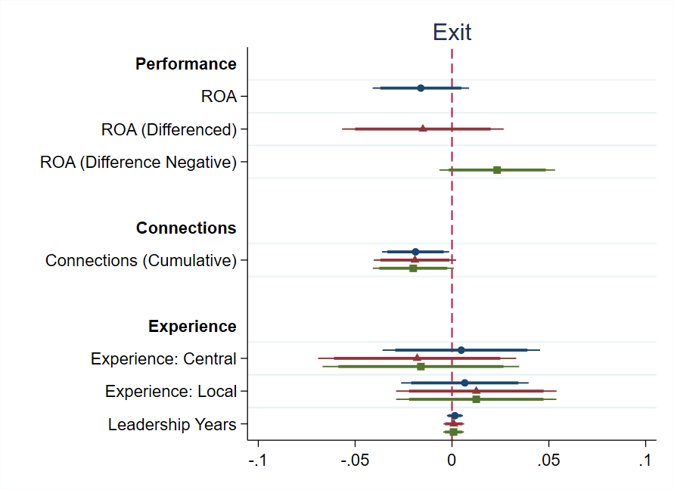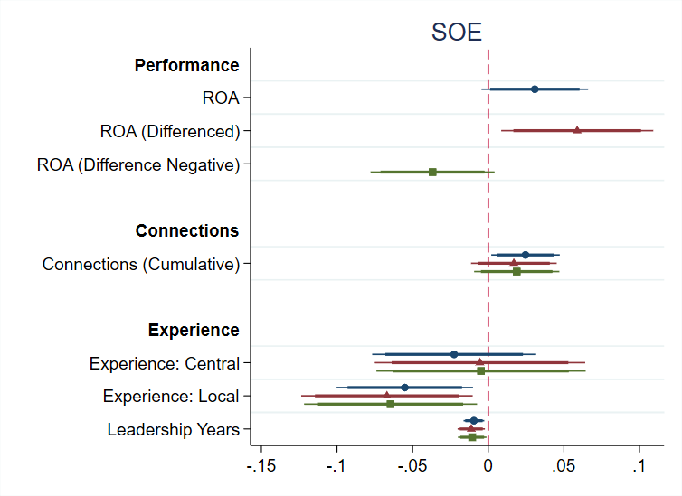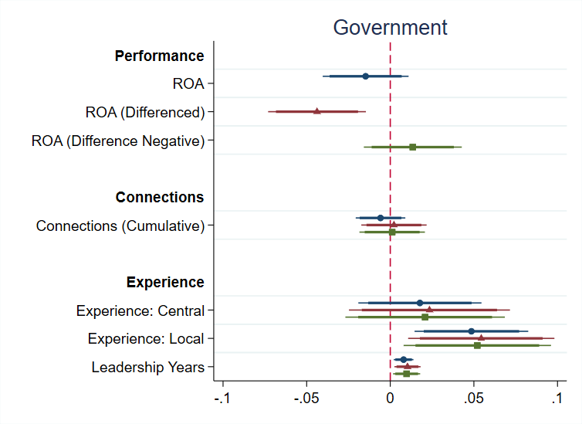
Staying in the state-owned economy estimated as the baseline option. Marginal effects predicted from the multinomial logit model. Full results available in appendix table A6.

In the three-level models, leadership years decrease the likelihood of staying in one’s executive position and increase the probability of moving to a government position. As in the power continuation models, however, this effect is small and disappears at longer durations of tenure (Figure A1). Previous experience in local government has a positive and significant impact on mobility into government positions. Having previously served in local government increases the probability of transferring to a government position, either at the local or central levels, by about five percent. These results suggest that one pattern in the personnel management of core central SOE leaders is from local government to central SOEs and finally back to government, whereas another pattern is simply staying within the state-owned economy for one’s entire career.
The three-level models also show positive correlations between political connectedness and staying in one’s position, similar to the power continuation findings (Table 2). Connections with the COD director and the central administration reduce exit by approximately three percent and increase the probability of staying in the state-owned economy by approximately four percent. The importance of connectedness with the COD director is further evidenced when controlling for other connections. When controlling for connections with SASAC directors as a robustness check, the COD connectedness measure remains statistically significant, with COD connectedness increasing the probability of staying in the state-owned sector compared to the other two outcomes by six percent (p=0.000). Political connectedness increases the probability of staying in one’s position, but not moving into government. While some might expect politically oriented regimes to have high levels of SOE leader interchange between the state and the economy, these results suggest that in China politically connected individuals are more likely to remain in the economy.
Similar to the political connectedness models, the number of patron connections also matters for maintaining one’s position in the three-level model. In particular, the more connections one has, the less likely one is to exit, with a marginal effect of 0.02 (p<0.033), and the more likely one is to stay in the state-owned sector. Beyond the bivariate models, these results highlight that leaders with patron connections stay in the state-owned economy rather than being pulled in to government. From the patron’s perspective, this suggests a strategy of oversight administration regimes keeping a broad base of potential allies across multiple sectors, rather than pooling them into the government bureaucracy, similar to the findings of Keller (2016).

Robustness Checks
For our main models, all three types of leaders—general manager, Party secretary, and chairman—are treated as equal. As a robustness check, we also evaluate the potential for position effects. All models were run with indicators for the three different positions. Chairmen were more likely to continue their executive leadership in the logit model (marginal effect 0.05 p=0.081) and less likely to exit in the multinomial model (marginal effect 0.05 p=0.02). This correlation is likely the result of time-relative patterns: at the beginning of the panel, most firms did not have a board of directors and therefore lacked a chairman position. The growing proportion of firms with boards and consequently chairmen over the course of the panel means a natural bias towards power continuation because our data are censored. Concurrent positions, holding more than one position at a time, increases power continuation (marginal effect 0.04 p=0.066) and decreases the likelihood of exit (marginal effect -0.03 p=0.048) and moving to government (marginal effect -0.04 p=0.017).
It is also possible that there are interaction effects between political connectedness and economic performance. Theoretically, a politically connected leader could be rewarded more for economic performance, or an unconnected leader could be rewarded less. We test this potential interaction dynamic and find no statistically significant interaction in any model.
The results presented above are robust to alternative measures and modeling forms. We included alternative measures of firm performance and test for a series of non-linear relationships with performance and interactions between performance and age. Our results remain the same. See the Appendix for a description of robustness checks.

Conclusion
As the state’s presence remains strong in economies worldwide, many governments use executive appointments to govern their SOEs. In this paper, we posit that systems of SOE executive appointments vary on a spectrum from market-oriented to political-oriented. Situating these systems relative to one another is an essential first step toward integrating the rich but fragmented country-based literature on SOE governance. Next, we investigate empirically how China—a substantively important case of high integration with the state apparatus and ruling elites—governs its SOEs, by conducting the first systematic analysis of political mobility for the leaders of the largest and most strategically important Chinese state firms. We find that better economic performance decreases the probability of a core central SOE leader exiting his executive role and increases the likelihood of transfer to another core central SOE. We also find that core central SOE leaders are more likely to stay in position if they possess informal connections to the political elites in charge of their evaluation, while those with previous local-level political experience are more likely to move into government.
Important areas for future research include exploring alternative measures of political connections and the determinants of core central SOE leaders’ initial appointments to executive leadership positions. One limitation of this analysis is that we do not include connections to Politburo members individually, but aggregate this to central Party relations generally. We believe the current measure of connections best captures the potential for positive work evaluation—the mechanism behind the connections hypothesis—when compared to alternative measures. A co-working measure would allow future researchers to create a broader measure of connections among central-level Party members, but at this time there is insufficient data and high potential for measurement error in comparing the two measurements. Future research, with sufficient data on core central SOE leaders’ work experience before their leadership position, would diversify and broaden our understanding of how political connections relate to mobility. This in turn would enable more fine-grained assessment of SOE leader appointment as an independent treatment on the firm, and the potential for political connections to drive the allocation of connected leaders to those SOEs likely to achieve better economic performance, independent of the effects of the executives themselves. Finally, additional cross-national research could evaluate the relative effects of political versus economic appointments in contexts with a mix of political- and market-oriented personnel management systems.
Overall, our findings suggest that in contexts where SOEs are highly politically integrated, governments can use personnel power as an instrument to pursue economic and political stability. In China, such stability is a top priority for the Party state and the officials whose careers it determines via the cadre management system. Expectations for SOE leaders to deliver on stability are evident in both executive evaluation and official discourse. In the Chinese context, we find that the Party state exercises personnel power to support its stability aims by deliberately keeping well-performing SOE leaders in the state-owned economy, retaining individuals who are connected with the leadership of supervising government and Party bodies, and rewarding those who accumulate government and Party training with transfers to government jobs with the potential for rank-based promotion. In contrast, in countries where SOEs are less integrated with the state apparatus and ruling elites, governments lack such personnel power and the leaders of SOEs are not easily used as tools. Instead, governments in such contexts may rely more heavily on other, more well-known methods—such as regulations, information reporting, and audits—to govern SOEs. By situating our findings about the Chinese case comparatively, we point the way forward for additional empirical analysis of SOE executive appointment systems in other countries.
Studying how governments use executive appointments to govern SOEs is more important than ever because these firms are increasingly active beyond national borders. While SOEs in natural resource industries like oil, gas, and mining have operated worldwide for decades, those in technology-based sectors like automobiles, electricity, nuclear power, transportation, and telecommunications have only recently entered international markets. Moreover, SOEs in which the government is a majority shareholder and over half of total assets are located overseas hail from both advanced capitalist and emerging economies, including firms such as Électricité de France, Singapore Telecommunications Ltd., and China Ocean Shipping Company. In addition to existing scholarship on SOE adaptation to host country institutions and regulations, studying governments’ personnel power over top executives is also essential to understand how globalizing SOEs behave overseas.

Acknowledgements
The authors thank Melanie Manion and Li-an Zhou for their comments on earlier versions of the paper and Zhan Chen, Yingtao Guo, Yufan Huang, Xinwen Lv, Mingwei Xu, and Jingxin Zhou for invaluable research assistance and input. We are also grateful for feedback from participants at the Conference on Political Selection at the National School of Development, Peking University (2018); Harvard-MIT-BU Cambridge Chinese Politics Research Workshop (2018); Harvard Kennedy School Ash Center Asia Fellows Seminar (2018); International Studies Association Annual Meeting (2019); and Indiana University-Chinese Academy of Social Sciences Research Symposium (2019).

References
Aharoni, Yair.1986. The Evolution and Management of State Owned Enterprises. Melrose, MA: Ballinger Publishing Company.
Bo, Zhiyue. 2013. “Paths to the Top Leadership in China: The Case of Provincial Leaders.” In Chien-wen Kou and Xiaowei Zang, eds., Choosing China’s Leaders. London: Routledge, 65-96.
Brødsgaard, Kjeld Erik. 2012. “Politics and Business Group Formation in China: The Party in Control?” The China Quarterly 211: 624–648.
Brødsgaard, Kjeld Erik, Paul Hubbard, Guilong Cai and Linlin Zhang. 2017. “China’s SOE Executives: Drivers of or Obstacles to Reform?” Copenhagen Journal of Asian Studies 35, no. 1: 52–75.
Central Organization Department (COD), Party-Building Research Institute. 1993. Dangjian
yanjiu zongheng tan [Party-Building Research Discussion]. Beijing: Dangjian duwu
chubanshe.
Chang, Eric C. and Sonia M.L. Wong. 2004. “Political Control and Performance in China’s Listed Firms.” Journal of Comparative Economics 32, no. 4: 617-636.
Chen, Jay Chih-Jou. 2006. “Elite Mobility in Post-Reform Rural China.” Issues and Studies 42, no. 2: 53–83.
Choi, Eun Kyong. 2012. “Patronage and Performance: Factors in the Political Mobility of Provincial Leaders in Post-Deng China.” The China Quarterly 212: 965–981.
Cuervo-Cazurra, Alvaro, Andrew Inkpen, Aldo Musacchio, and Kannan Ramaswamy. 2014. “Governments as Owners: State-owned Multinational Companies.” Journal of International Business Studies. 45, no. 8: 919-942.
Clayton, Matthew C., Jay C. Hartzell, and Joshua Rosenberg. 2005. “The Impact of CEO Turnover on Equity Volatility.” The Journal of Business 78, no. 5: 1779-1808.
Dewenter, Kathryn L., and Paul H. Malatesta. 2001. “State-Owned and Privately Owned Firms: An Empirical Analysis of Profitability, Leverage, and Labor Intensity.” American Economic Review 91, no. 1: 320-334.
Ehrlich, Isaac, Georges Gallais-Hamonno, Zhiqiang Liu, and Randall Lutter. 1994. “Productivity Growth and Firm Ownership: An Analytical and Empirical Investigation.” Journal of Political Economy 102, no. 5: 1006-1038.
Ennser-Jedenastik, Laurenz. 2014. “The Politics of Patronage and Coalition: How Parties Allocate Managerial Positions in State-Owned Enterprises.” Political Studies 62, no. 2: 398-417.
Filatov, Alexander, Vladimir Tutkevich, and Dmitry Cherkaev. 2005. “Board of Directors at State-Owned Enterprises (SOE) in Russia.” OECD Russian Corporate Governance Roundtable.
Frydman, Roman, Cheryl Gray, Marek Hessel, and Andrzej Rapaczynski. 1999. “When Does Privatization Work? The Impact of Private Ownership on Corporate Performance in the Transition Economies.” The Quarterly Journal of Economics 114, no. 4: 1153-1191.
Hertog, Steffen. 2010. “Defying the Resource Curse: Explaining Successful State-Owned Enterprises in Rentier States.” World Politics 62, no. 2: 261-301.
Hsueh, Roselyn. 2011. China’s Regulatory State: A New Strategy for Globalization. Ithaca, NY: Cornell University Press.
Jiang, Junyan. 2018. “Making Bureaucracy Work: Patronage Networks, Performance Incentives, and Economic Development in China.” American Journal of Political Science 62, no. 4: 982-999.
Keller, Franziska Barbara. 2016. “Moving Beyond Factions: Using Social Network Analysis to Uncover Patronage Networks Among Chinese Elites.” Journal of East Asian Studies 16, no. 1: 17-41.
Kowalski, Przemyslaw, Max Büge, Monika Sztajerowska and Matias Egeland. 2013. “State-Owned Enterprises: Trade Effects and Policy Implications.” OECD Trade Policy Papers, no. 147.
Landry, Pierre F. 2003. “The Political Management of Mayors in Post-Deng China.” Copenhagen Journal of Asian Studies 17: 31–58.
Landry, Pierre F. 2008. Decentralized Authoritarianism in China: The Communist Party’s Control of Local Elites in the Post-Mao Era. New York: Cambridge University Press.
Landry, Pierre F., Xiaobo Lü, and Haiyan Duan. 2018. “Does Performance Matter? Evaluating Political Selection Along the Chinese Administrative Ladder.” Comparative Political Studies 51, no. 8: 1074-1105.
Lee, Ching Kwan. 2017. The Specter of Global China: Politics, Labor, and Foreign Investment in Africa. Chicago: University of Chicago Press.
Leutert, Wendy. 2018. “The Political Mobility of China’s Central State-Owned Enterprise Leaders.” The China Quarterly 233: 1-21.
Leutert, Wendy. 2020. “State-Owned Enterprises in Contemporary China.” In Luc Bernier,
Florio Massimo, and Philippe Bance. Routledge Handbook of State-Owned Enterprises.
New York: Routledge.
Li, Chen. 2016. “Holding ‘China Inc.’ Together: The CCP and the Rise of China’s Yangqi.” The China Quarterly 288: 927–949.
Li, Hongbin, and Li-An Zhou. 2005. “Political Turnover and Economic Performance: The Incentive Role of Personnel Control in China.” Journal of Public Economics 89: 1743-62.
Li, Lianjiang. 2019. “The Cadre Resignation Tide in the Wake of the 18th Party Congress.” China: An International Journal 17, no. 3: 188-199.
Lin, Li-Wen. 2017. “Reforming China’s State-Owned Enterprises: From Structure to People.” The China Quarterly 229: 107-129.
Lin, Li-Wen, and Curtis J. Milhaupt. 2013. “We Are the (National) Champions: Understanding the Mechanisms of State Capitalism in China.” Stanford Law Review 65: 697-759.
Liou, Chih-shian, and Chung-min Tsai. 2017. “The Dual Role of Cadres and Entrepreneurs in China: The Evolution of Managerial Leadership in State-Monopolized Industries.” Asian Survey 57, no. 6: 1058-1085.
Maskin, Eric, Yingyi Qian, and Chenggang Xu. 2000. “Incentives, Information, and Organizational Form.” The Review of Economic Studies 67, no. 2: 359-378.
Meyer, David, Victor C. Shih, and Jonghyuk Lee. 2016. “Factions of Different Stripes: Gauging the Recruitment Logics of Factions in the Reform Period.” Journal of East Asian Studies 16, no. 1: 43-60.
Meyer, Klaus E., Yuan Ding, Jing Li, and Hua Zhang. 2018. “Overcoming Distrust: How State-Owned Enterprises Adapt their Foreign Entries to Institutional Pressures Abroad,” 211-251. In Alvaro Cuervo-Cazurra. Cham, ed., State-Owned Multinationals: Governments in Global Business, Switzerland: Palgrave Macmillan.
Ministry of Finance. 2017. Zhongguo caizheng nianjian [China Financial Yearbook].
OECD. 2013. “Boards of Directors of State-Owned Enterprises: An Overview of National Practices.” Paris: OECD.
OECD. 2017. “The Size and Sectoral Distribution of State-Owned Enterprises.” Paris: OECD.
Rhodium Group. 2018. The China Dashboard, https://aspi.gistapp.com/china-dashboard/.
Rosen, Daniel H., Wendy Leutert and Shan Guo. 2018. Missing Link: Corporate Governance in China’s State Sector. San Francisco: Asia Society.
Schoenherr, David. 2019. “Political Connections and Allocative Distortions.” Journal of Finance 74, no. 2: 543-586.
Scissors, Derek. 2017. “Chinese Investment: Revenge of the State.” Washington DC: American Enterprise Institute.
Shih, Victor C., Christopher Adolph and Mingxing Liu. 2012. “Getting Ahead in the Communist Party: Explaining the Advancement of Central Committee Members in China.” American Political Science Review 106, no. 1: 166-187.
State-owned Assets Supervision and Administration Commission (SASAC). 2003. Zhongyang qiye jingying yeji kaohe zanxing banfa fudao jiangzuo [Guiding Lectures on Temporary Measures for Performance Evaluation of Central Enterprises]. Beijing: Jingji kexue chubanshe.
State-owned Assets Supervision and Administration Commission (SASAC). 2018. Guoqi gaige licheng, 1978-2018 [The Course of Chinese State-Owned Enterprise Reform, 1978-2018], vol. 2. Beijing: Zhongguo jingji chubanshe.
Tian, Lihui, and Saul Estrin. 2008. “Retained State Shareholding in Chinese PLCs: Does Government Ownership Always Reduce Corporate Value?” Journal of Comparative Economics 36, no. 1: 74-89.
Vortherms, Samantha A. 2019. “Disaggregating China’s Local Political Budget Cycles: ‘Righting’ the U.” World Development 114: 95-109.
Wang, Changyun. 2005. “Ownership and Operating Performance of Chinese IPOs.” Journal of Banking and Finance 29, no 7: 1835-1856.
World Bank. 2014. “Corporate Governance of State-Owned Enterprises: A Toolkit.” Washington,
DC: World Bank.
Wu, Mark. 2016. “The ‘China, Inc.’ Challenge to Global Trade Governance,” Harvard International Law Journal 57, no. 2: 261-324.
Yang, Ruilong, Yuan Wang, and Huihua Nie. 2012. “‘Zhun guanyuan’ de pusheng jizhi: laizi zhongguo yangqi de zhengju” [The Political Promotion for Quasi-Government Officers: Evidence from Central State-owned Enterprises in China]. Guanli shijie [Management World] 3: 223-33.
Zhang, Chunlin. 2019. “How Much Do State-Owned Enterprises Contribute to China’s GDP and
Employment?” Washington DC: World Bank.
Zhang, Jun, Qi Zhang and Zhikuo Liu. 2017. “The Political Logic of Partial Reform of China’s State-Owned Enterprises.” Asian Survey 57, no. 3: 395-415.
Zhou, Li-an. 2018. “‘Guanchang + shichang’ yu zhongguo zengzhang gushi” [‘Bureaucratic + Economic Markets’ and China’s Growth Story). Shehui [Chinese Journal of Sociology] 38, no. 2: 1-45.

Personnel Power: Governing State-Owned Enterprises

Online Appendix

Sample Selection
We choose the start year of 2003 because that is the year in which the State-Owned Assets Supervision Commission (SASAC) was established and central SOEs first existed as a discrete set of firms for analysis. The end year of 2017 is selected to coincide with the end of Xi Jinping’s first five-year term; it is also the most recent year for which data is available. The core central SOEs are a stable grouping across the study’s 15 year time period, with fewer than five firms ceasing to exist due to mergers. If firm ceases to exist, its leaders are no longer coded and included in the sample starting from the following year.

A leader is marked as starting in a given year if his appointment begins before July, that is in the first half of the year. The exit rule also uses the June/July cut off, as it is standard in the field. This means our dataset drops any leaders who worked less than six months from 2003 to 2017, which includes 13 individuals: eight of whom either exited in 2003 or started in 2017 and five of whom had a total tenure of less than six months. When SOE leaders leave their positions they also exit the dataset; if they are transferred outside of the state sector but then are appointed back to another core central SOE executive position, they reenter the dataset.

Measuring Mobility
Biographical information about these leaders’ backgrounds and their career trajectories was compiled from their official CVs, available on company websites or publicly online, as well as media reports and the Chinese Political Elites Database hosted by National Chengchi University. All of the models presented in the paper include all three types of leaders pooled into one sample. Robustness checks verify that there are no systematic differences between types of leaders.

Measuring ROA
Regulatory authorities do not require public disclosure of performance data for overall enterprise groups. SASAC does publish performance data for entire enterprise groups in its annual yearbooks, but these data are highly suspect and reported inconsistently. We therefore use performance data for the publicly listed subsidiaries of core central SOEs to proxy for performance of the overall business group. Since publicly listed subsidiaries typically contain the best quality productive assets from core central SOEs, their performance represents a conservative upper bound for assessing that of the overall enterprise group.
To measure ROA, we calculate core central SOEs’ largest listed subsidiaries’ ratio of net profit to net assets, using data from the WIND financial database. Using ROA (level) may unintentionally capture variation in firm performance not attributed to leader quality, creating measurement error.
Return on assets (ROA) is available via stock market data portals, but these data show high variance and significant outliers, increasing concerns about data quality. Our calculated measure has significantly fewer outliers than the available ROA data and, once extreme outliers are removed from the WIND ROA data, there is a strong correlation between the existing data and our own measure (ρ=0.78). For data completeness and due to concern about outliers, we use our calculated ROA measure throughout this analysis. Four core central SOEs did not have subsidiaries listed domestically in mainland China but did have subsidiaries listed on stock exchanges in Hong Kong and New York; we included performance data from overseas listed subsidiaries for these firms. Of the 54 firms in the dataset, two rely on data from the Hong Kong stock exchange: Shenhua Group and China Unicom. An additional two firms rely on data from the New York Stock Exchange: China Telecom and China Mobile. Where data from international stock markets were used, an additional control for foreign stock exchange is included.

Modeling Strategies
Existing studies model these measures using ordered logit models. These models assume exit is less desirable than maintaining one’s position or a lateral transfer and that promotions are most sought after. While these models may be appropriate for some samples, we decided to use the less structured multinomial model for two reasons. First, core central SOE leaders are officials relatively advanced in their careers—the average age is 55—and they operate in an area of the Chinese bureaucracy in which no clear lines of promotion exist. Promotion to a ministerial-ranked position within the state-owned economy is not possible; lateral moves to another central-level SOE can represent either a holding pattern in advance of impending retirement or a step forward in one’s career. Moreover, there may be cases in which appointments to government may be less of a career advancement than remaining in the state-owned economy. Second, ordered logit models have strict assumptions of parallel regression or proportional odds, meaning there is a parallel trend between different outcomes. As a robustness check, we repeated our models with an ordered logit and each model clearly violates this assumption. Therefore, we follow existing work to conclude that a multinomial logit is more appropriate than an ordered logit to model political mobility.
An alternative modeling strategy option is survival analysis using event history. There are three reasons why we choose a discrete model rather than a classic event history analysis. First, the logit and multinomial logit models are the standard in the field for research on elite management in China. Multinomial models allow our results to be more readily comparable to the existing literature to facilitate the accumulation of knowledge.
Second, event history analysis, including parametric, non-parametric, and the semi-parametric Cox proportional hazard models, all assume a continuous time measure. The fundamental assumption is that failure can occur at any time and that the time units are sufficiently close to each other. Time units that are more discrete in nature, including year intervals, undermine these assumptions and should be modeled using a discrete model, such as the one presented in the original analysis. Presumably, this shortcoming could be ignored, and year-based data modeled continuously if there is a sufficient spread of events over a broad timeline. Indeed, the maximum “time to failure,” the longest tenure in our dataset, is 18 years, which is a borderline case for treating time continuously. Looking at the distribution of observations, however, suggests a skew to the data: the average tenure is only 6 years. This skew combined with the non-continuous time parameter makes us wary of fitting a model with a continuous assumption.
Finally, we are concerned about the appropriateness of event history analysis with our measure of connections. Connectedness variables are always defined as 1 at the start and cannot extend after 10, which biases the underlying hazard function. This combined with the skewed, discrete time variable greatly increases our concern of using event history analysis as the primary, or even robustness check, using the connectedness variable over the entire sample.
We evaluate the potential appropriateness of an event history analysis by applying a discrete-time event history analysis to our sample. Looking at the results of this analysis, we find further evidence that the underlying assumptions of the event history analysis may be inappropriate. Appendix Table A8 shows that the time elements in our sample do not act linearly. Only three time periods are statistically significant: the second, third, and ninth years of tenure. In these years, exit is less likely.

Robustness Checks
The other source for data on firm performance is from SASAC itself. SASAC publishes annual yearbooks with data including performance measures that SASAC itself uses for evaluation criteria, such as preservation of state-owned asset value. These data, however, are reported highly irregularly both across time and firms and are more susceptible than stock exchange data to political manipulation or even falsification, due to lack of information disclosure requirements. This creates serious concerns about omitted data not being missing at random, so we do not use this data in our main models or attempt to impute missing values because this would risk introducing bias. As a robustness check, we repeat the analysis using the SASAC data on the highly restricted sample. Both preservation of assets and business group income are negatively correlated with the likelihood of transfer to a government position (Table A9). These findings broadly support our finding of performance being correlated with staying in one’s position, specifically not being pulled into government.
The models presented above utilize one measure of performance, ROA, to test the performance hypothesis. There are other performance measures that both SASAC leaders and the COD could use to assess performance, meaning our proxy would not appropriately capture performance. To validate the findings, we repeat the analysis using return on equity (ROE) and earnings per share (EPS), two other standard indicators of firm performance. The results with the other indicators are similar, although both ROE and EPS are negatively correlated with exit whereas the correlation is not statistically significant for ROA. Model diagnostics suggest that ROA models are a better fit for the data than ROE and EPS is less comparable across stock exchanges, so we use ROA in our final models presented above.
Formal connections could be picking up endogenous career paths. If a COD director wants to promote a given SOE leader, they could appoint the leader to a government commission during their tenure to make future government appointment more likely. If this were the case, the formal experience indicator would be picking up informal connections. As a robustness check, we re-run the models with an indicator for previous government experience, which only includes government experience prior to their SOE leadership role. The results remain unchanged.
Informal connections with China’s key leaders have also been measured on a looser basis, by looking at networks within the CCP. Instead of the patron-based model presented above, we could include standard measures for factions related to Hu Jintao and Xi Jinping based on work experience within the CCP. A leader is defined as being in Hu Jintao’s network if they have experience in the Communist Youth League, which Hu Jintao headed as First Secretary early in his career (1984-1985). Leaders are considered connected with Xi Jinping if they have previous work experience in Shanghai or Zhejiang, where Xi served as party secretary (2002-2007 and 2007, respectively). We prefer the patron method discussed above because of its closer ties to an actual working relationship and because the sample size of Youth League and Shanghai/Zhejiang connections is small in our dataset (11 and 17 respectively).
Finally, we find limited evidence of position effects: that serving in particular executive leadership positions—or combinations of them—affects political mobility. The sample presented here includes individuals serving in all three types of core central SOE leadership posts—Party secretary, general manager, and chair of the board of directors, if one exists—and all possible combinations of these positions. It is possible that political mobility outcomes may vary by leadership position. For example, the Party secretary of a firm may be more closely integrated into the CCP and be more likely to move into the government. To test for position effects, we implement a model with the full specifications above, but including indicators for positions. On average, Party secretaries have a slightly higher rate of exiting the dataset than chairmen and a slightly higher probability of staying in their position than chairmen, all else equal, but these differences are small. Having concurrent positions did not increase the likelihood of promotion on their own, likely because concurrent positions with the chairman position increased in later years of the panel, due to a developmental trend of an increasing number of core central SOEs establishing boards of directors at the holding company level throughout the 2000s (Rosen, Leutert and Guo 2018, 21). We control for this possible time effect through the Xi administration control variable.

References
Allison, Paul D. 1982. “Discrete-Time Methods for the Analysis of Event Histories.” Sociological Methodology 13. 61-98.
Bo, Zhiyue. 2013. “Paths to the Top Leadership in China: The Case of Provincial Leaders.” In Chien-wen Kou and Xiaowei Zang, eds., Choosing China’s Leaders. London: Routledge, 65-96.
Brødsgaard, Kjeld Erik, Paul Hubbard, Guilong Cai and Linlin Zhang. 2017. “China’s SOE Executives: Drivers of or Obstacles to Reform?” Copenhagen Journal of Asian Studies 35 (1): 52–75.
Choi, Eun Kyong. 2012. “Patronage and Performance: Factors in the Political Mobility of Provincial Leaders in Post-Deng China.” The China Quarterly 212: 965–981.
Huang, Yasheng. 1999. Inflation and Investment Controls in China: The Political Economy of Central-Local Relations During the Reform Era. New York: Cambridge University Press.
Landry, Pierre F. 2008. Decentralized Authoritarianism in China: The Communist Party’s Control of Local Elites in the Post-Mao Era. New York: Cambridge University Press.
Li, Hongbin, and Li-An Zhou. 2005. “Political Turnover and Economic Performance: The Incentive Role of Personnel Control in China.” Journal of Public Economics 89: 1743-62.
Rosen, Daniel H., Wendy Leutert, and Shan Guo. 2018. Missing Link: Corporate Governance in China’s State Sector. San Francisco: Asia Society of Northern California.
Shih, Victor C., Christopher Adolph and Mingxing Liu. 2012. “Getting Ahead in the Communist Party: Explaining the Advancement of Central Committee Members in China.” American Political Science Review 106 (1): 166-187.

Tables and Figures
Table A1: List and Summary Statistics of Central SOEs Included in Sample

Name of SOE Business Group | Industry* | Years in Dataset | Av. ROA** | Av. Diff. ROA
China National Nuclear Corporation | Comprehensive industry | 2003-2017 | 0.44 | 0.0241
China Nuclear Industry Construction Corporation | Architecture and Engineering | 2003-2017 | 0.16 | -0.0095
China Aerospace Science and Technology Corporation | Aerospace and Defense | 2003-2017 | 0.45 | -0.0064
China Aerospace Science and Industry Corporation | Aerospace and Defense | 2003-2017 | 0.28 | 0.0062
China Aviation Industry Corporation | Aerospace and Defense | 2009-2017 | 0.25 | -0.0104
China State Shipbuilding Corporation | Construction machinery and heavy trucks | 2003-2017 | 0.28 | -0.0094
China Shipbuilding Industry Corporation | Construction machinery and heavy trucks | 2003-2017 | 0.21 | -0.0129
China North Industries Group Corporation | Aerospace and Defense | 2003-2017 | 0.27 | 0.0514
China North Industries Group Corporation | Motor vehicle parts and equipment | 2003-2017 | 0.65 | -0.0531
China Electronics Technology Group Corporation | Aerospace and Defense | 2003-2017 | 0.72 | -0.0337
China National Petroleum Corporation | Comprehensive oil and gas | 2003-2017 | 0.81 | -0.0892
China Petrochemical Corporation | Comprehensive oil and gas | 2003-2017 | 0.55 | 0.0163
National China Offshore Oil Corporation | Comprehensive oil and gas | 2003-2017 | 0.42 | 0.0595
State Grid Corporation | Electricity | 2003-2017 | 0.29 | -0.0267
China Southern Power Grid Co. Ltd. | Electricity | 2003-2017 | 0.58 | -0.0098
China Huaneng Group Corporation | Electricity | 2003-2017 | 0.35 | 0.0041
China Datang Corporation | Electricity | 2003-2017 | 0.21 | -0.0298
China Huadian Corporation | Electricity | 2003-2017 | 0.16 | 0.0175
China Guodian Corporation | Electricity | 2003-2017 | 0.28 | 0.0122
China Power Investment Corporation | Electricity | 2003-2014 | 0.26 | -0.0067
China Three Gorges Corporation | Electricity | 2003-2017 | 0.66 | -0.0069
Shenhua Group Co. Ltd | Coal and consumer fuel | 2004-2017 | 1.05 | -0.0293
China Telecom Corporation | Integrated telecommunications services | 2003-2017 | 0.37 | -0.0027
China United Network Communications Group Co., Ltd. | Communication equipment | 2003-2017 | 0.11 | -0.0367
China Electronics Information Industry Group Co. Ltd. | Electronic Manufacturing Service | 2003-2017 | 0.25 | 0.0726
China FAW Corporation | Automobile Manufacturing | 2003-2017 | 0.37 | -0.0111
Dongfeng Motor Company | Automobile Manufacturing | 2003-2017 | 0.32 | -0.0840
China First Heavy Machinery Group Corporation | Industrial Machinery | 2004-2017 | 0.00 | 0.0003
Harbin Electric Group Company | Heavy electrical equipment | 2003-2017 | -0.44 | 0.0806
China Dongfang Electric Group Co. Ltd. | Heavy electrical equipment | 2003-2017 | 0.27 | 0.0123
Anshan Iron and Steel Group Company | Steel | 2003-2017 | 0.29 | 0.0718
Baosteel Group Co., Ltd. | Steel | 2003-2016 | 0.56 | -0.0486
Wuhan Iron and Steal (Group) Company | Steel | 2003-2016 | 0.42 | -0.0949
Aluminum Corporation of China | Aluminum | 2003-2017 | 0.31 | -0.1402
China Ocean Shipping (Group) Corporation | Shipping | 2003-2016 | 0.38 | -0.0876
China Shipping (Group) Corporation | Shipping | 2003-2015 | 0.21 | -0.2020
China National Aviation Corporation | Aviation | 2003-2017 | 0.27 | 0.0962
China Eastern Airlines Corporation | Aviation | 2003-2017 | 0.01 | -0.0545
China Southern Airlines Corporation | Aviation | 2003-2017 | 0.14 | -0.0125
China Sinochem Corporation | Trading company and industrial product distributor | 2003-2017 | 0.49 | -0.0382
COFOC Corporation | Consumer Goods Distributor | 2003-2017 | -0.15 | 0.0198
China Minmetals Corporation | Trading company and industrial product distributor | 2003-2017 | -0.02 | 0.1439
China General Technology (Group) Holding Co., Ltd. | trading company and industrial product distributor | 2003-2017 | 0.54 | 0.0062
China State Construction Engineering Corporation | Architecture and Engineering | 2003-2017 | 0.33 | 0.0045
National Development and Investment Corporation | Comprehensive industry | 2003-2017 | 0.13 | 0.0093
China Merchants Group Co., Ltd. | Comprehensive industry | 2003-2017 | 0.10 | 0.0057
China Resources (Group) Co., Ltd. | Investment Holding and Property Lease | 2003-2017 | 0.44 | -0.0140
China Hong Kong China Travel Service Corporation | Hotels, resorts and luxury cruise ships | 2003-2016 | 0.46 | -0.0466
National Nuclear Power Technology Corporation | Electricity | 2007-2015 | 0.59 | -0.4498
Commercial Aircraft Corporation of China Limited*** | Aerospace and Defense | 2008-2017
China Grain Reserve Management Corporation*** | Comprehensive industry | 2004-2016
China Second Heavy Machinery Group Corporation*** | Industrial Machinery | 2003-2013

* WIND industry coding of largest subsidiary
** ROA refers to the ROA of the largest listed subsidiary. Amount listed is averaged over the years in the sample
***Firms excluded from the analysis because of data availability.

Table A2: Key Central Leaders
Central Party | SASAC Directors | Central Organization Department Directors
Hu Jintao  (2003-2012) | Li Rongrong  (2003-2010) | He Guoqiang  (2002-2007)
Xi Jinping  (2012-present) | Wang Yong  (2011-2013) | Li Yuanchao  (2008-2012)
 | Zhang Yi  (2014-2015) | Zhao Leji  (2013-2017)

Table A3: Summary Statistics

Variable | Obs | Mean (SD) | Min | Max
Power Continuation | 1,045 | 0.899 (0.302) | 0 | 1
3-level
Exit | 75 | 0.068
Stay SOE | 991 | 0.895
Government | 41 | 0.037
ROA | 1,045 | 0.319 (0.490) | -2.4 | 2.99
Connected
Central | 1,109 | 0.609 (0.488) | 0 | 1
SASAC | 1,109 | 0.340 (0.490) | 0 | 1
COD | 1,109 | 0.444 (0.497) | 0 | 1
Cumulative | 1,109 | 1.45 (1.239) | 0 | 3
Party School | 1,045 | 0.138 (0.345) | 0 | 1
Leadership Years | 1,045 | 5.133 (3.285) | 1 | 18
Central Experience | 1,045 | 0.133 (0.340) | 0 | 1
Local Experience | 1,045 | 0.167 (0.373) | 0 | 1
Age | 1,045 | 54.970 (5.200) | 40 | 69
Graduate Degree | 1,045 | 0.393 (0.489) | 0 | 1

Table A4: Full Model Results for Power Continuation Logit Models
 | (1) | (2) | (3) | (4) | (5)
ROA | 0.399* |  | 0.468**
 | (0.207) |  | (0.233)
ROA (Diff) |  | 0.606* |  | 0.546
 |  | (0.312) |  | (0.332)
ROA |  |  |  |  | -0.436*
(Diff Neg) |  |  |  |  | (0.243)
Connections |  |  | 0.292** | 0.222 | 0.242
(Cumulative) |  |  | (0.149) | (0.169) | (0.169)
Experience:
Central |  |  | -0.206 | -0.0705 | -0.0928
 |  |  | (0.388) | (0.421) | (0.414)
Local |  |  | 0.104 | 0.0419 | 0.0551
 |  |  | (0.266) | (0.291) | (0.292)
Leadership |  |  | -0.0908** | -0.0711 | -0.0663
Years |  |  | (0.0428) | (0.0481) | (0.0481)
Party School | 0.310 | 0.337 | 0.578 | 0.615 | 0.578
 | (0.492) | (0.519) | (0.623) | (0.639) | (0.637)
Age | 2.197*** | 2.309*** | 1.923*** | 2.061*** | 2.015***
 | (0.369) | (0.445) | (0.387) | (0.461) | (0.469)
Age Squared | -0.0222*** | -0.0230*** | -0.0194*** | -0.0206*** | -0.0201***
 | (0.00348) | (0.00417) | (0.00366) | (0.00432) | (0.00440)
Grad. Degree | 0.141 | 0.171 | 0.249 | 0.298 | 0.289
 | (0.278) | (0.289) | (0.322) | (0.338) | (0.337)
Xi | -0.160 | -0.374 | 0.0313 | -0.185 | -0.130
 | (0.225) | (0.245) | (0.228) | (0.251) | (0.239)
Constant | -50.26*** | -53.57*** | -43.63*** | -47.30*** | -45.86***
 | (9.547) | (11.63) | (10.07) | (12.12) | (12.35)
Observations | 1,109 | 881 | 1,045 | 826 | 826
Pseudo R2 | 0.213 | 0.206 | 0.240 | 0.222 | 0.220
Robust standard errors clustered at individual level in parentheses
*** p<0.01, ** p<0.05, * p<0.10
Models include foreign exchange indicator for data source and industry fixed effects.

Table A5: Logit Models of Political Connectedness and Power Continuation

 | (1) | (2) | (3) | (4) | (5) | (6) | (7) | (8)
Connections
Central Admin. | 0.499* | 0.433
 | (0.294) | (0.321)
SASAC Director |  |  | 0.471 | 0.366
 |  |  | (0.337) | (0.347)
COD Director |  |  |  |  | 0.682** | 0.686**
 |  |  |  |  | (0.323) | (0.332)
Cumulative |  |  |  |  |  |  | 0.321** | 0.292**
 |  |  |  |  |  |  | (0.139) | (0.149)
ROA |  | 0.493** |  | 0.469** |  | 0.442** |  | 0.468**
 |  | (0.229) |  | (0.234) |  | (0.225) |  | (0.233)
Experience
Central | -0.110 | -0.202 | -0.0745 | -0.160 | -0.153 | -0.247 | -0.115 | -0.206
 | (0.344) | (0.382) | (0.341) | (0.380) | (0.354) | (0.397) | (0.349) | (0.388)
Local | 0.115 | 0.109 | 0.214 | 0.210 | 0.179 | 0.154 | 0.111 | 0.104
 | (0.250) | (0.264) | (0.244) | (0.256) | (0.246) | (0.263) | (0.251) | (0.266)
Leadership Years | -0.109*** | -0.115*** | -0.119*** | -0.125*** | -0.0930** | -0.0933** | -0.0846** | -0.0908**
 | (0.0375) | (0.0402) | (0.0369) | (0.0398) | (0.0416) | (0.0441) | (0.0399) | (0.0428)
Party School | 0.412 | 0.545 | 0.389 | 0.518 | 0.342 | 0.485 | 0.449 | 0.578
 | (0.565) | (0.621) | (0.548) | (0.597) | (0.539) | (0.592) | (0.566) | (0.623)
Age | 1.853*** | 1.916*** | 1.907*** | 1.966*** | 1.961*** | 2.014*** | 1.864*** | 1.923***
 | (0.362) | (0.383) | (0.362) | (0.382) | (0.373) | (0.394) | (0.368) | (0.387)
Age Squared | -0.0188*** | -0.0193*** | -0.0193*** | -0.0198*** | -0.0198*** | -0.0202*** | -0.0189*** | -0.0194***
 | (0.00341) | (0.00363) | (0.00340) | (0.00362) | (0.00351) | (0.00373) | (0.00346) | (0.00366)
Graduate Degree | 0.203 | 0.249 | 0.177 | 0.229 | 0.204 | 0.244 | 0.196 | 0.249
 | (0.289) | (0.323) | (0.286) | (0.319) | (0.290) | (0.321) | (0.288) | (0.322)
Xi | 0.0515 | 0.0372 | 0.0400 | 0.0226 | -0.0576 | -0.0664 | 0.0478 | 0.0313
 | (0.217) | (0.229) | (0.209) | (0.223) | (0.217) | (0.231) | (0.215) | (0.228)
Constant | -40.99*** | -43.10*** | -42.41*** | -44.37*** | -43.91*** | -45.76*** | -41.66*** | -43.63***
 | (9.434) | (9.930) | (9.464) | (9.938) | (9.759) | (10.24) | (9.658) | (10.07)
Observations | 1,165 | 1,045 | 1,165 | 1,045 | 1,165 | 1,045 | 1,165 | 1,045
Pseudo R2 | 0.242 | 0.237 | 0.241 | 0.236 | 0.244 | 0.240 | 0.246 | 0.240
Robust standard errors clustered at individual level in parentheses
*** p<0.01, ** p<0.05, * p<0.10
Models include foreign exchange indicator for data source and industry fixed effects.

Table A6: Multinomial Performance Models of Exit, Stay in SOE, or Transfer to Government

 | (1) | (3) | (4) | (6) | (7) | (9) | (10) | (12) | (13) | (15)
VARIABLES | Exit | Gov’t | Exit | Gov’t | Exit | Gov’t | Exit | Gov’t | Exit | Gov’t
ROA | -0.389 | -0.460 |  |  | -0.392 | -0.458
 | (0.287) | (0.410) |  |  | (0.307) | (0.406)
ROA (Difference) |  |  | -0.409 | -1.187*** |  |  | -0.358 | -1.187***
 |  |  | (0.445) | (0.406) |  |  | (0.470) | (0.402)
ROA (Difference Negative) |  |  |  |  |  |  |  |  | 0.523 | 0.371
 |  |  |  |  |  |  |  |  | (0.331) | (0.398)
Connections (Cumulative) |  |  |  |  | -0.451** | -0.189 | -0.417* | 0.0465 | -0.439* | 0.0170
 |  |  |  |  | (0.213) | (0.235) | (0.237) | (0.266) | (0.237) | (0.264)
Experience: Central | 0.0154 | 0.532 | -0.461 | 0.630 | 0.126 | 0.541 | -0.378 | 0.618 | -0.339 | 0.540
 | (0.476) | (0.583) | (0.564) | (0.657) | (0.493) | (0.579) | (0.571) | (0.665) | (0.569) | (0.648)
Experience: Local | 0.0141 | 1.474*** | 0.169 | 1.472** | 0.191 | 1.476*** | 0.311 | 1.471** | 0.310 | 1.385**
 | (0.371) | (0.516) | (0.438) | (0.585) | (0.402) | (0.520) | (0.469) | (0.590) | (0.472) | (0.583)
Leadership Years | 0.101** | 0.292*** | 0.0784 | 0.266*** | 0.0412 | 0.243*** | 0.0274 | 0.277*** | 0.0241 | 0.260**
 | (0.0475) | (0.0772) | (0.0508) | (0.0927) | (0.0503) | (0.0885) | (0.0592) | (0.104) | (0.0598) | (0.108)
Party School | -2.359 | 0.892 | -2.385 | 0.749 | -2.778 | 0.840 | -2.787 | 0.756 | -2.757 | 0.651
 | (1.635) | (0.618) | (1.769) | (0.588) | (1.792) | (0.621) | (1.967) | (0.595) | (1.887) | (0.594)
Age | -3.639*** | 0.776 | -4.095*** | 0.582 | -3.549*** | 0.821 | -4.054*** | 0.583 | -4.063*** | 0.701
 | (0.669) | (0.629) | (0.770) | (0.656) | (0.641) | (0.627) | (0.749) | (0.657) | (0.755) | (0.709)
Age Squared | 0.0364*** | -0.00853 | 0.0405*** | -0.00683 | 0.0354*** | -0.00894 | 0.0400*** | -0.00685 | 0.0401*** | -0.00790
 | (0.00647) | (0.00608) | (0.00742) | (0.00639) | (0.00620) | (0.00605) | (0.00721) | (0.00641) | (0.00728) | (0.00690)
Graduate Degree | -1.088* | 0.421 | -1.272** | 0.767* | -1.055* | 0.394 | -1.254** | 0.780 | -1.265** | 0.691
 | (0.588) | (0.424) | (0.597) | (0.465) | (0.555) | (0.428) | (0.574) | (0.478) | (0.561) | (0.462)
Xi | -0.133 | 0.104 | 0.0263 | 0.398 | -0.182 | 0.000607 | -0.116 | 0.433 | -0.134 | 0.282
 | (0.335) | (0.395) | (0.390) | (0.449) | (0.318) | (0.412) | (0.374) | (0.438) | (0.354) | (0.434)
Constant | 83.98*** | -22.02 | 96.26*** | -16.78 | 82.82*** | -22.68 | 96.23*** | -16.93 | 96.12*** | -20.02
 | (16.79) | (16.20) | (19.34) | (16.72) | (16.07) | (16.12) | (18.84) | (16.74) | (18.99) | (18.08)
Observations | 1,044 | 1,044 | 825 | 825 | 1,044 | 1,044 | 825 | 825 | 825 | 825
Pseudo R2 | 0.332 | 0.332 | 0.337 | 0.337 | 0.338 | 0.338 | 0.341 | 0.341 | 0.334 | 0.334
Robust standard errors in parentheses
*** p<0.01, ** p<0.05, * p<0.1
Models with ROA include foreign exchange indicator for data source and industry fixed effects.

Table A7: Multinomial Connections Models of Exit, Stay in SOE, or Transfer to Government

 | (1) | (3) | (4) | (6) | (7) | (9) | (10) | (12)
VARIABLES | Exit | Gov’t | Exit | Gov’t | Exit | Gov’t | Exit | Gov’t
Connected
Central | -0.793* | -0.240
 | (0.421) | (0.524)
SASAC Director |  |  | -0.741 | -0.204
 |  |  | (0.513) | (0.491)
COD Director |  |  |  |  | -0.681* | -0.424
 |  |  |  |  | (0.412) | (0.548)
Connections (Cumulative) |  |  |  |  |  |  | -0.451** | -0.189
 |  |  |  |  |  |  | (0.213) | (0.235)
ROA | -0.437 | -0.465 | -0.362 | -0.459 | -0.365 | -0.448 | -0.392 | -0.458
 | (0.296) | (0.409) | (0.322) | (0.409) | (0.285) | (0.406) | (0.307) | (0.406)
Experience: Central | 0.113 | 0.537 | 0.0316 | 0.507 | 0.0869 | 0.597 | 0.126 | 0.541
 | (0.489) | (0.579) | (0.475) | (0.581) | (0.498) | (0.602) | (0.493) | (0.579)
Experience: Local | 0.224 | 1.472*** | 0.00522 | 1.490*** | 0.0965 | 1.447*** | 0.191 | 1.476***
 | (0.393) | (0.513) | (0.386) | (0.518) | (0.381) | (0.514) | (0.402) | (0.520)
Leadership Years | 0.0690 | 0.269*** | 0.0755 | 0.278*** | 0.0587 | 0.250*** | 0.0412 | 0.243***
 | (0.0500) | (0.0880) | (0.0490) | (0.0793) | (0.0503) | (0.0841) | (0.0503) | (0.0885)
Party School | -2.722 | 0.864 | -2.696 | 0.861 | -2.378 | 0.889 | -2.778 | 0.840
 | (1.761) | (0.618) | (1.828) | (0.623) | (1.637) | (0.618) | (1.792) | (0.621)
Age | -3.459*** | 0.816 | -3.648*** | 0.819 | -3.657*** | 0.709 | -3.549*** | 0.821
 | (0.649) | (0.635) | (0.660) | (0.622) | (0.658) | (0.619) | (0.641) | (0.627)
Age Squared | 0.0347*** | -0.00890 | 0.0363*** | -0.00894 | 0.0365*** | -0.00786 | 0.0354*** | -0.00894
 | (0.00627) | (0.00612) | (0.00637) | (0.00601) | (0.00637) | (0.00596) | (0.00620) | (0.00605)
Graduate Degree | -1.075* | 0.418 | -1.072* | 0.406 | -1.072* | 0.396 | -1.055* | 0.394
 | (0.566) | (0.425) | (0.569) | (0.423) | (0.580) | (0.428) | (0.555) | (0.428)
Xi | -0.228 | 0.0432 | -0.167 | 0.0475 | -0.0764 | 0.104 | -0.182 | 0.000607
 | (0.327) | (0.418) | (0.319) | (0.425) | (0.332) | (0.395) | (0.318) | (0.412)
Constant | 79.92*** | -22.82 | 85.01*** | -22.94 | 85.00*** | -19.98 | 82.82*** | -22.68
 | (16.29) | (16.33) | (16.56) | (15.98) | (16.50) | (16.00) | (16.07) | (16.12)
Observations | 1,044 | 1,044 | 1,044 | 1,044 | 1,044 | 1,044 | 1,044 | 1,044
Pseudo R2 | 0.336 | 0.336 | 0.335 | 0.335 | 0.335 | 0.335 | 0.338 | 0.338
Robust standard errors in parentheses
*** p<0.01, ** p<0.05, * p<0.1
Models with ROA include foreign exchange indicator for data source and industry fixed effects.

Table A8: Discrete Time Analysis
 | Exit | Fitted Odds | Fitted Hazard
Leadership Year | (â_{j}) | e^{(áj)} | 1/(1+e^{(-áj)})
2 | -3.168** | 0.0421 | 0.0404
 | (1.328)
3 | -2.240* | 0.1065 | 0.0963
 | (1.272)
4 | -1.490
 | (1.253)
5 | -0.999
 | (1.247)
6 | -1.427
 | (1.265)
7 | -1.136
 | (1.263)
8 | -0.882
 | (1.268)
9 | -3.219** | 0.04 | 0.0385
 | (1.591)
10 | -0.747
 | (1.282)
11 | -0.363
 | (1.294)
12 | -0.223
 | (1.319)
13 | -0.693
 | (1.387)
14 | -0.154
 | (1.409)
15 | -0.916
 | (1.647)
Observations | 1,125
Pseudo R2 | 0.0795
*** p<0.01, ** p<0.05, * p<0.1

Figure A1: Effects of Leadership Tenure on Key Outcomes
Panel A Power Continuation Panel B Multinomial: Government
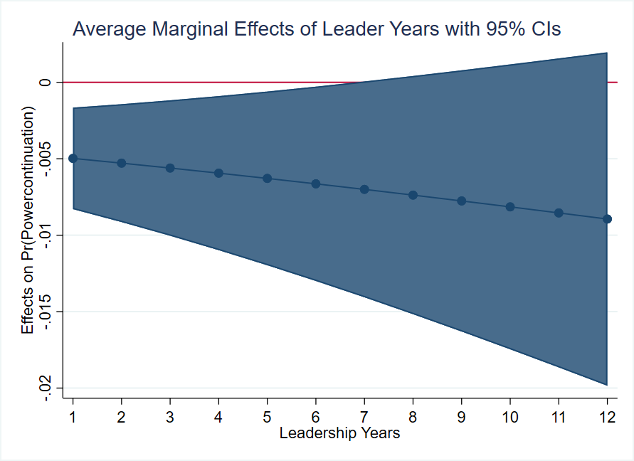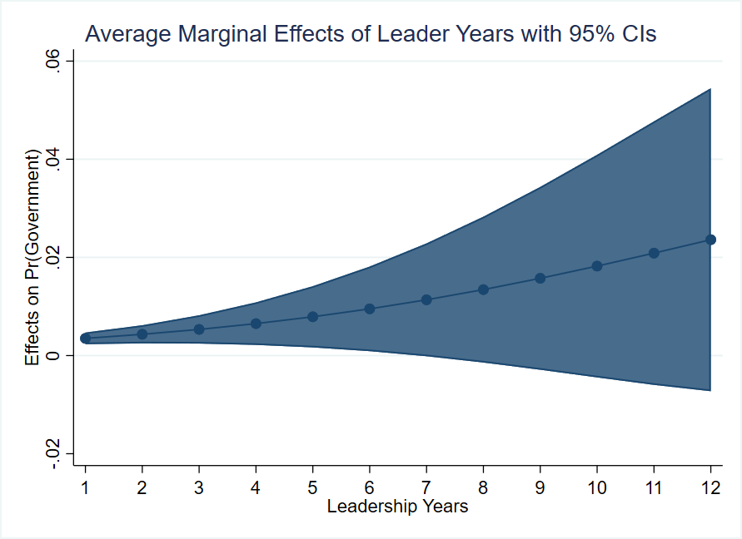

Table A9 Robustness Check: Alternative Measures of Firm Performance
 | (1) | (2) | (3) | (4) | (5) | (6)
VARIABLES | Power Continuation | Power Continuation | Exit | Gov’t | Exit | Gov’t
Asset Preservation | -0.000886 |  | 0.00886 | -0.0484**
Rate (SASAC) | (0.00844) |  | (0.00660) | (0.0215)
Income (SASAC) |  | 1.09e-05 |  |  | -1.77e-07 | -3.81e-07*
 |  | (5.37e-05) |  |  | (1.19e-07) | (2.18e-07)
ROA | 0.755** | 0.495 | -0.484 | -0.0617 | -0.380 | 0.149
 | (0.362) | (0.304) | (0.653) | (0.681) | (0.410) | (0.610)
Observations | 515 | 604 | 538 | 538 | 633 | 633
Industry FE | Yes | Yes | Yes | Yes | Yes | Yes
Pseudo R2 | 0.296 | 0.273 | 0.291 | 0.291 | 0.292 | 0.292
Robust standard errors in parentheses
*** p<0.01, ** p<0.05, * p<0.1
All models include ROA, cumulative connections, party school, leadership years, central and local experience, age and age squared, graduate degree, and Xi Jinping era. Models include foreign exchange indicator for data source.

Table A10: Non-linear Robustness Checks
 | (1) | (2) | (3) | (4) | (5) | (6) | (7) | (8)
VARIABLES
ROA | 0.452* | 0.943 | 0.451
 | (0.235) | (2.434) | (0.284)
ROA X ROA | -0.0427
 | (0.170)
ROA X Age |  | -0.00824
 |  | (0.0424)
ROA X Above Retirement |  |  | 0.0624
 |  |  | (0.479)
ROA (Diff) |  |  |  | 0.453* | 5.063* | 0.904***
 |  |  |  | (0.256) | (3.071) | (0.246)
ROA (Diff) X ROA (Diff) |  |  |  | -0.221
 |  |  |  | (0.162)
ROA (Diff) X Age |  |  |  |  | -0.0785
 |  |  |  |  | (0.0558)
ROA (Diff) X Above Retirement |  |  |  |  |  | -0.949
 |  |  |  |  |  | (0.593)
ROA (Diff, negative) |  |  |  |  |  |  | -0.436* | -0.756*
 |  |  |  |  |  |  | (0.243) | (0.387)
ROA (Diff, negative) X Above Retirement |  |  |  |  |  |  |  | 0.587
 |  |  |  |  |  |  |  | (0.510)
Above Retirement Age |  |  | -0.0809 |  |  | -0.119 |  | -0.415
 |  |  | (0.440) |  |  | (0.483) |  | (0.600)
Age | 1.925*** | 1.927*** | 1.876*** | 2.112*** | 2.059*** | 2.099*** | 2.015*** | 1.984***
 | (0.387) | (0.390) | (0.518) | (0.468) | (0.469) | (0.623) | (0.469) | (0.625)
Observations | 1,045 | 1,045 | 1,045 | 826 | 826 | 826 | 826 | 826
Industry FE | Yes | Yes | Yes | Yes | Yes | Yes | Yes | Yes
Pseudo R2 | 0.240 | 0.240 | 0.240 | 0.225 | 0.225 | 0.227 | 0.220 | 0.223
*** p<0.01, ** p<0.05, * p<0.1
Errors clustered at the individual level. All models include ROA, cumulative connections, party school, leadership years, central and local experience, age and age squared, graduate degree, and Xi Jinping era. Models include foreign exchange indicator for data source.

Figure A2 Robustness Check: Linear Trends of Performance Over Age
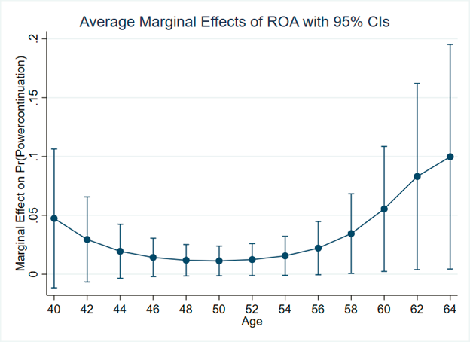

Approximately one quarter of the firms on the 2018 Fortune Global 500 are state-owned. SOEs are among the largest companies in emerging economies as well as advanced capitalist states Authors’ calculations based on Fortune 2018 Global 500 list.
OECD (2017); World Bank (2014).
Dewenter and Malatesta (2001); Ehrlich et al. (1994); Frydman et al. (1999).
Aharoni (1986).
World Bank (2014).
Filatov, Tutkevich, and Cherkaev (2005).
OECD (2017), Kowalski et al. (2013).
Estimated SOE contribution to GDP is for 2017. Zhang (2019). Calculations for SOE share of industrial assets and presence in equity markets use Bloomberg data about companies listed on the Shanghai and Shenzhen stock exchanges, as of June 2018. Rhodium Group (2018).
Scissors (2017).
For a comparative overview of national appointment practices for SOE boards of directors in 31 countries, see OECD (2013).
World Bank (2014), 187.
World Bank (2014), 187.
Hertog (2010).
Filatov, Tutkevich, and Cherkaev (2005).
Schoenherr (2019).
Ennser-Jedenastik (2014).
SASAC, established in 2003 as a special commission of the State Council, is responsible for overseeing China’s central SOEs. A current list of central SOEs (in Chinese) is available at http://www.sasac.gov.cn/n2588035/n2641579/n2641645/index.html.
See Brødsgaard (2012) for a list of the core central SOEs.
The Chinese bureaucracy has 27 ranks divided into 11 different levels. Leaders of core central SOEs are of vice-ministerial rank equivalence, on the same level as prefecture-level city leaders. Vice-ministerial rank is typically the highest possible rank for Chinese SOE leaders. There are a handful of executives who hold a higher rank by virtue of their previous positions, but such cases are rare. Leutert (2018), 5.
Hsueh (2011).
OECD (2017).
Lin and Milhaupt (2013).
Brødsgaard (2012), 633-634. This division of authority over enterprise administration (granted to SASAC) and top-level personnel management (reserved for the COD) was a political compromise reached after debate in the 1990s and early 2000s over the design of a central-level system to manage state-owned assets. For discussion of the specific methods the COD proposed to ensure continued Party participation and influence in SOE decision-making in the decade leading up to SASAC’s establishment, see COD (1993), 139-153.
Only two female executives appear in our dataset: Wang Yinxiang of China Aviation Group Corporation and Xie Qihua of Baosteel (now Baowu Steel).
Bo (2013), 67.
Between 2003 and 2012, 4.3 per cent of core central SOE leaders were transferred to vice-ministerial rank positions and .4 per cent were promoted, compared with rates of 8.7 per cent lateral transfer and 4.0 per cent promotion for executive vice-governors (vice-governors serving on a provincial standing committee) with the equivalent vice-ministerial rank. Meyer, Shih and Lee (2016). Of core central SOE leaders serving between 2003 and 2012, 10.1 percent exceeded the mandatory retirement age of 60. In contrast, only about 1 percent of mayors and municipal Party secretaries between 2000 and 2010 and less than 1 percent of provincial Party secretaries and no provincial governors between 2003 and 2012 exceeded it. Vortherms (2019); provincial official statistics provided by Li-an Zhou, Peking University, via personal correspondence in 2016.
Li (2019). The authors are not aware of any core central SOE leaders who have assumed a formal position in a private company after their exit.
Landry (2008); Landry, Lü and Duan (2018); Li and Zhou (2005); Maskin, Qian and Xu (2000).
Zhou (2018).
Chen (2006); Landry (2003); Shih, Adolph, and Liu (2012).
Choi (2012); Landry, Lü and Duan (2018).
Jiang (2018).
Brødsgaard (2012); Leutert (2018); Li (2016); Lin (2017); Liou and Tsai (2017); Zhang, Zhang and Liu (2017).
Lin (2017); Yang, Wang and Nie (2013).
Brødsgaard et al. (2017).
Ministry of Finance (2017); Rosen, Leutert and Guo (2018).
SASAC, Yangqi zhan yi tujian [Illustrated Compendium of Central State-owned Enterprises’ War Against the Epidemic], April 24, 2020; SASAC, Guoziwei caiqu youli cuoshi weihu gupiao shichang wending [SASAC Takes Effective Measures to Safeguard Stock Market Stability], 8 July 2015.
SASAC, Guoziwei yu zhongyang qiye qianding jingying yeji zerenshu Hao Peng qiangdiao yao quanli yi ben wen zengzhang qieshi fahui hao “wendingqi” zuoyong [SASAC Signed Responsibility Contracts for Operating Performance with Central Enterprises, Hao Peng Emphasized the Need to Go All Out to Stabilize Growth and Effectively Play the Role of “Stabilizer”], June 13, 2019.
Executive turnover can precipitate sustained increases in stock market volatility due to uncertainty about changes in a firm’s strategy after an executive’s departure or concerns about their successor’s ability. Clayton et al (2005).
Even Chinese utility State Grid, which enjoys a de facto monopoly over domestic electricity transmission and presumably has minimal financial imperative to compete abroad, now does business in nearly 40 countries worldwide. State Grid, “Overseas Projects,” http://www.sgcc.com.cn/html/sgcc_main_en/col2017112821/column_2017112821_1.shtml, accessed November 30, 2020.
Lee (2017) describes this objective as profit “optimization” rather than maximization (33).
The four principles in rank order are: 1) maximization of operational profits; 2) maximization of operational efficiency; 3) sustainable development; 4) maintaining and increasing asset value. SASAC (2003), 43.
The other three evaluation areas are political quality (zhengzhi suzhi), unity and cooperation (tuanjie xiezuo), and work-style image (zuofeng xingxiang). COD and SASAC, Zhongyang qiye lingdao banze he lingdao renyuan zonghe kaohe pingjia banfa (shixing) [Central Enterprise Leadership Team and Leaders Comprehensive Evaluation Assessment Measures (Trial),” November 26, 2010.
SASAC, Zhongyang qiye fuzeren jingying yeji kaohe banfa [Central SOE Responsible Persons Performance Evaluation Measures], issued December 14, 2018 and effective April 1, 2019.
While SASAC’s system of annual grades is widely known and lists of the highest performing firms are announced, grades for individual executives are not publicly disclosed. For the most recent list of A-rated firms, see SASAC, “2019 niandu yangqi qiye fuzeren jingying yeji kaohe A ji qiye mingdan” [2019 Annual Central SOE Responsible Persons Operating Performance Evaluation A-Level Enterprise List], July 20, 2020.
While all central SOE leaders are expected to preserve and increase the value of state-owned assets, SASAC also considers variation in size (by assets), industry, geographic location (e.g. central SOEs located in Hong Kong), and form of corporate organization (e.g. whether a firm is organized as a wholly state-owned or a joint stock corporation). SASAC (2003), 38-41. The Xi administration continues to explore evaluating central SOEs differently based on classifying them as industrial enterprise groups (shiti chanye jituan), investment companies (touzi gongsi), or operating companies (yunying gongsi); however, central SOE classifications are not public and these efforts are ongoing. SASAC (2018), 212-213. In some cases, the COD solicits officials’ preferences before determining personnel appointments. Interview with retired ministerial-level official in Hong Kong in January 2016 (Institutional Review Board approval on file with authors).
Jiang (2018).
Shih, Adolph, and Liu (2012).
Keller (2016).
Core central SOEs include approximately fifty firms; the exact number depends on the year because of restructuring and mergers within our sample timeframe. For a detailed discussion of the sample, data sources, and measurement, see the Appendix.
See Figure 2 for the administrative and personnel authority structure that distinguishes core central SOEs from non-core SOEs.
Two leaders in our sample die while in office. One, Wu Shengfu of China First Heavy Industries, died at age 51 in an apparent suicide in connection with a corruption probe. Zhu Wenqian, “Death of Company Boss Under Investigation May Be Suicide,” China Daily, 4 August 2015.
The most common retirement ages in the sample are 61, 62, and 63, making up 17, 14, and 35 percent of retirements, respectively.
Xinhua News, Zhongyang jiwei jianchabu wangzhan yi fabu yangqi bei diaocha lingdao 64 ren [CCDI Inspection Department Website Announced 64 Central State-Owned Enterprise Leaders Have Been Investigated], 5 January 2016.
Li and Zhou (2005).
Landry (2008).
In the sample of fifty-three core central SOEs, only three did not have a publicly listed subsidiary during the study period: China National Erzhong Group, Sinograin, and Commercial Aircraft Corporation of China (COMAC). The leaders of these firms are dropped from the analysis. In core central SOEs, the board chairman typically serves jointly as the head of the flagship subsidiary, thereby reducing potential concern that subsidiary performance is a function of a different executive.
Return on assets (ROA) refers to the ratio of net income to total assets. ROA is the most common accounting measure for profitability and a standard measure of firm performance. It is used widely in studies of Chinese firms, both private and public. See for example Chang and Wong (2004); Tian and Estrin (2008); Wang (2005).
Jiang (2018); Keller (2016); Landry, Lü and Duan (2018); Meyer, Shih and Lee (2016).
Jiang (2018); Landry, Lü and Duan (2018); Meyer, Shih and Lee (2016).
See Appendix Table A2 for specific SASAC and COD director names and tenure dates.
A COD official expressed that its Enterprise Division, the internal department responsible for the management of core central SOE leaders, is “extremely familiar” with these individuals. Personal communication with COD official, January 2019.
Since mandatory retirement age is not strictly applied, a continuous measure of age more accurately tracks the Chinese context. As a robustness check, we evaluated whether those who stay in their position after retirement age had better connections than the average leader and there is no correlation.
An alternative modeling strategy is event history analysis. We do not conduct a survival analysis for multiple reasons, preferring to use the standard models used for elite management in China. A discrete event history analysis suggests event history analysis may be inappropriate for our dataset (see Appendix for discussion). Multivariate models allow us to compare multiple outcomes without superimposing which outcome is better than another.
Calculated from the cumulative connections model. Models include all control variables and leadership experience variables. Results robust to the inclusion of performance measures.
See Appendix Figure A1 Panel A for graph of marginal effects of tenure.
Connectedness at the central level and with the COD director are highly correlated (ρ=0.7). Because of multicollinearity concerns, estimates of COD connectedness while controlling for other connections does not include the central connectedness measure.
Research showing that the majority of core central SOE executives are “state-owned industry careerists,” many of whom rose to leadership after years working inside the same companies, alleviates if not entirely obviates concerns of external manipulation. Leutert (2018), 8.
Cuervo-Cazurra et al. (2014), 920.
Ibid., 920.
Meyer et al. (2018).
Landry (2008); Shih, Adolph and Liu (2012).
For example, while the mean firm average net profit from 2003 to 2017 is 8 billion RMB, it ranges from -236 million RMB to 107 billion RMB, signaling significant variation in profitability across firms in the sample.
Brødsgaard et al. (2017); Huang (1999); Li and Zhou (2005).
See for example Bo (2002); Choi (2012); Landry (2008). Another possible modeling strategy is a linear probability model. We choose not to implement this for two reasons. First, we do not wish to impose a strict ordering on our outcomes, as discussed above. Second, the sample size is relatively limited and while linear probability models and logistic models do converge asymptotically, we do not wish to incur additional bias in our smaller sample.
Allison (1982).

